Online Shopping Store
Project Documentation

Project Team

Sondos Mohamed Saqr
Radwa Ali Metwally
Yasmine Hassan Sayed
Youssef Ibrahim Zahran
Walaa Atef Ahmed
Ziad Islam Sabry

1. Project Requirements
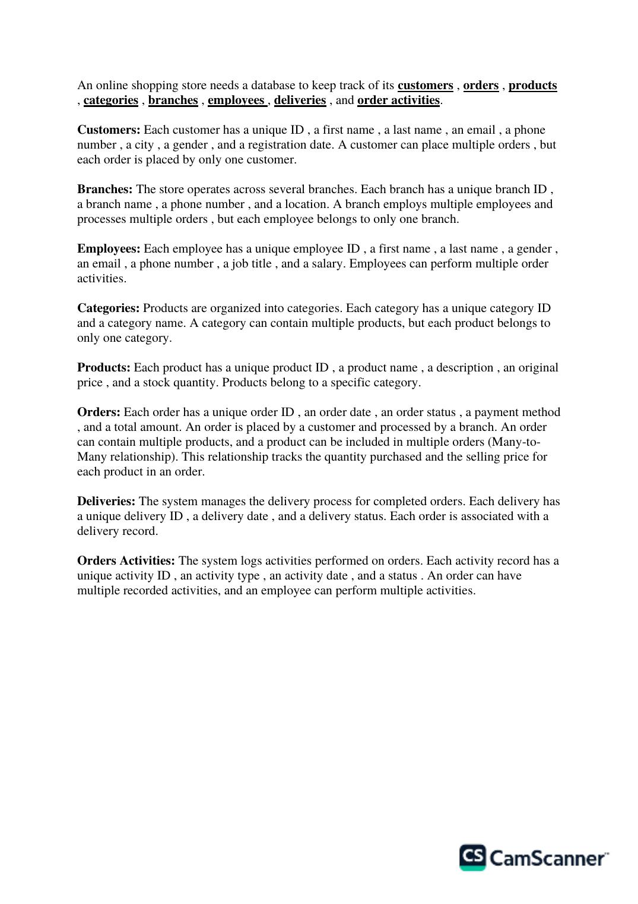
Original project file — page 1 of 3

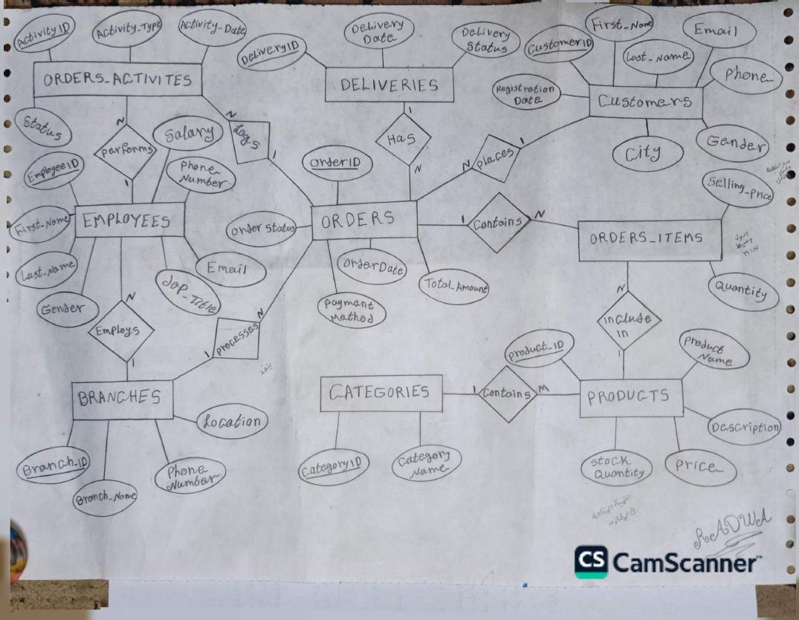
Original project file — page 2 of 3
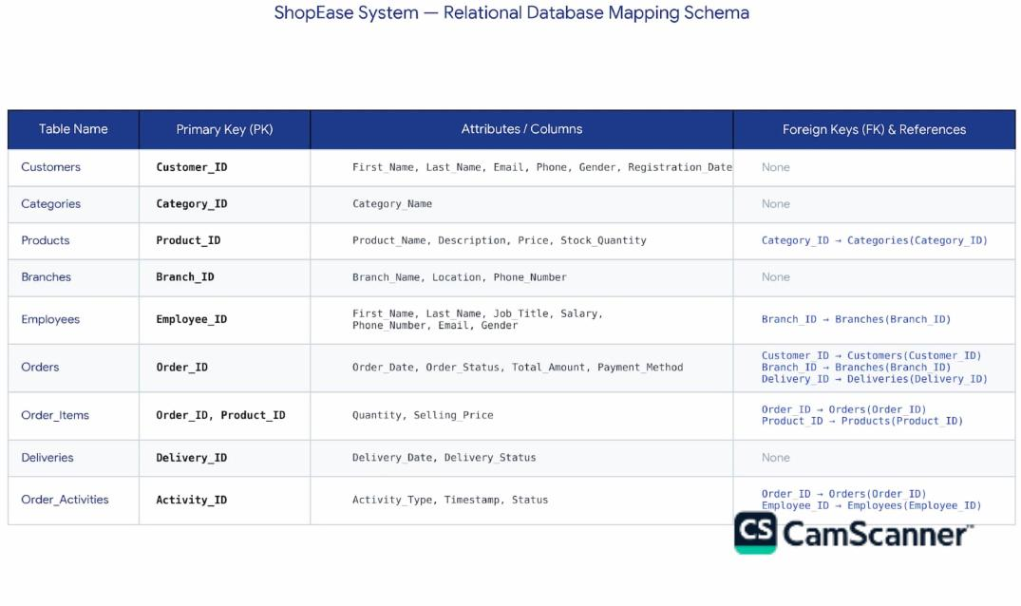
Original project file — page 3 of 3

2. SQL — Steps to Create the Database
# | Step
1 | Create Database
2 | Create Tables
3 | Insert values in Tables
4 | Check the first name, last name and city in the Customer table for extra spaces (TRIM)
5 | UPDATE: remove the existing spaces
6 | Display the Customers table after the update
7 | SELECT the current city name and the suggested name after the update
8 | UPDATE the letters of the city names (the way they are written)
9 | Display the Customers table after the city update
10 | Display the Phone_Number values that have problems in Customers (before changing the datatype)
11 | Update datatype of column phone to CHAR(11)
12 | Display Table branches
13 | Delete extra spaces (LTRIM) in Branch_Name, Location
14 | Update the letter casing of Location
15 | Delete the country code from Phone_Number
16 | Display the Phone_Number values that have problems in Branches (before changing the datatype)
17 | Update datatype phone to CHAR(11)
18 | Display the table after the update
19 | Display Table product
20 | Delete extra spaces (TRIM) in product_name, Description
21 | Display Table Employees
22 | Delete extra spaces (LTRIM) in First_Name, Last_Name, Job_Title, Gender
23 | Update the letter casing of First_Name, Last_Name, Job_Title
24 | Display the Phone_Number values that have problems
25 | Update datatype phone to CHAR(11)
26 | Display the Table after the update
27 | Display Table Deliveries
28 | Remove extra spaces (TRIM) in Status
29 | Update the letter casing of Delivery_Status
30 | Display the table after the update
31 | Display Table Order_Activities
32 | Remove extra spaces and update the letter casing of Activity_Type, Status
33 | Display the Table after the update
34 | Remove extra spaces and update the letter casing of Order_Status, Payment_Method
35 | Display the Table after the update
36 | Handle the outlier values in the Orders Item table

3. Power Query — Data Cleaning

1. Table: Branch
Column | Transformation Steps
Name | Capitalized → Replace → Trim
Location | Add Custom (use if, else if, Text.Contains) → Capitalized → Reordered → Removed → Renamed
Phone | Replace

2. Table: Categories
Column | Transformation Steps
Name | Capitalized → Trim → Add Conditional

3. Table: Customer
Column | Transformation Steps
Name | Merge → Capitalized
Gender | Replace
City | Add Conditional
Date | Change Type

4. Table: Deliveries
Column | Transformation Steps
Date | Change Type
Status | Replace

5. Table: Employees
Column | Transformation Steps
Name | Merge
Gender | Add Custom

6. Table: Activities
Column | Transformation Steps
Date | Change Type

7. Table: Items
Column | Transformation Steps
Quantity | Extract Before → Change Type → Absolute Value
Price | Replace → Change Type → Absolute Value

8. Table: Orders
Column | Transformation Steps
Date | Change Type
Status | Replace
Payment | Replace → Capitalized

9. Table: Product
Column | Transformation Steps
Name | Replace → Trim
Quantity | Extract Before → Change Type → Absolute Value

4. Data Cleaning and Preparation
# | Section | Tasks
1 | Customers | - Clean Email values.  - Clean and standardize Gender values.
2 | Employees | - Clean Salary values.  - Clean and standardize Gender values.
3 | Products | - Clean Price values.  - Check Stock_Quantity for outliers.  - Use 99th-percentile capping to handle extreme Stock_Quantity values.  - Do not delete product rows.
4 | Order Items | - Calculate Total_Amount using:  Quantity × Selling_Price
5 | Orders | - Calculate the total amount for each order.  - Group Order Items by OrderID.  - Sum Total_Amount for each OrderID.  - Merge the calculated totals with the Orders table.  - Use a left join to keep all orders.
6 | Data Validation | - Check rows and columns.  - Check duplicate IDs.  - Check missing values.  - Check numeric columns.  - Check negative values.  - Validate the final Total_Amount values.
7 | Final Output | - Use the cleaned DataFrames as the final data.  - Export the cleaned data to Excel.  - The final Excel file is ready for the next step.

5. SQL Insights
# | SQL Functions — Steps
1 | Queries: Select data from the Customers table and filtered it using WHERE, DISTINCT, LIKE and BETWEEN.
2 | Aggregate Functions: Used COUNT, AVG, MAX, MIN to get the number of orders.
3 | Used GROUP BY on customer ID to get the number of orders, total spending and the average.
4 | Used ORDER BY DESC and LIMIT 10 to get the top 10 orders.
5 | Split orders into high (5000 or more) and medium (2000 or more), then counted how many orders are in each group.
6 | Subqueries: Find the orders above the average amount and the order with the highest amount.
7 | Joined orders with customers using LEFT JOIN, RIGHT JOIN and INNER JOIN, and calculated the average and total spending per customer.
8 | Text, Null: Used CONCAT, UPPER, LOWER on customer data, and COALESCE and IF to handle e-mails.
9 | Multi-table Joins: Joined orders with branches, deliveries, customers.

6. Database Insights & Exploratory Data Analysis
Project: Multi-Sheet Database Analysis
File: clean_project.xlsx

# | Section | Tasks
1 | Setup | - Import Pandas, NumPy, Matplotlib, and Seaborn.  - Configure the visualization style.  - Set the Excel file path.
2 | Load Database | - Read the Excel workbook.  - Display all sheet names.  - Load all sheets into DataFrames.  - Check the number of rows and columns in each sheet.  - Display the database structure and column names.
3 | Customer Analysis | - Analyze the total number of registered customers.  - Check customer gender distribution.  - Identify the top cities by customer count.  - Summarize customer demographic and geographic patterns.
4 | Employee Analysis | - Calculate the total monthly payroll.  - Calculate the average employee salary.  - Calculate the average salary by job title.  - Compare salary levels across different job titles.
5 | Sales & Revenue Analysis | - Calculate Total_Price using:  Quantity × Selling_Price  - Calculate total revenue.  - Calculate total units sold.  - Calculate the average selling price per unit.
6 | Order Analysis | - Analyze the distribution of order statuses.  - Identify completed, pending, and cancelled orders.  - Analyze customer payment methods.  - Compare the use of cash, credit cards, and digital wallets.
7 | Delivery Analysis | - Analyze delivery status distribution.  - Check successfully delivered orders.  - Review orders that are in transit or preparing for dispatch.  - Identify delivery and cancellation patterns.
8 | Visualizations | - Create a bar chart for the top cities by customer count.  - Create a pie chart for payment method preferences.  - Create a box plot to compare salary distributions by job title.  - Create a histogram with KDE for product catalog price distribution.  - Create a histogram with KDE for actual selling price distribution.  - Compare catalog prices with actual selling prices.  - Create a scatter plot for Order Quantity vs. Total Revenue.
9 | Insights & Recommendations | - Interpret the results of each analysis.  - Identify important customer, sales, payment, salary, and delivery patterns.  - Compare product prices with actual selling prices.  - Analyze the relationship between order quantity and revenue.  - Provide data-driven business recommendations based on the visual and quantitative insights.
10 | Final Output | - Keep the analyzed DataFrames and generated visualizations as the final analysis output.  - Use the results to support business decision-making.

7. Power Pivot
# | Step
1 | First, I took the file and ran it (Run) in SQL so that it loads into my Schema.
2 | Second, I created a connection between Excel and SQL.
3 | After the data was connected, I went to the Power Pivot menu and used Add to Data Model for all the files, so they enter the data model and appear inside Power Pivot.
4 | After all the files entered and appeared in Power Pivot, I opened Diagram View to create the relationships between the tables.
5 | Then I wrote all the DAX functions that I created, such as SUM, CALCULATE, COUNTROWS, DIVIDE, AVERAGE.
6 | After finishing the DAX functions, I went to the PivotTable and placed the things I created with DAX in the Rows and in the Values.
7 | Finally, I created the KPIs, the Scatter, and the Charts.

8. Dashboards
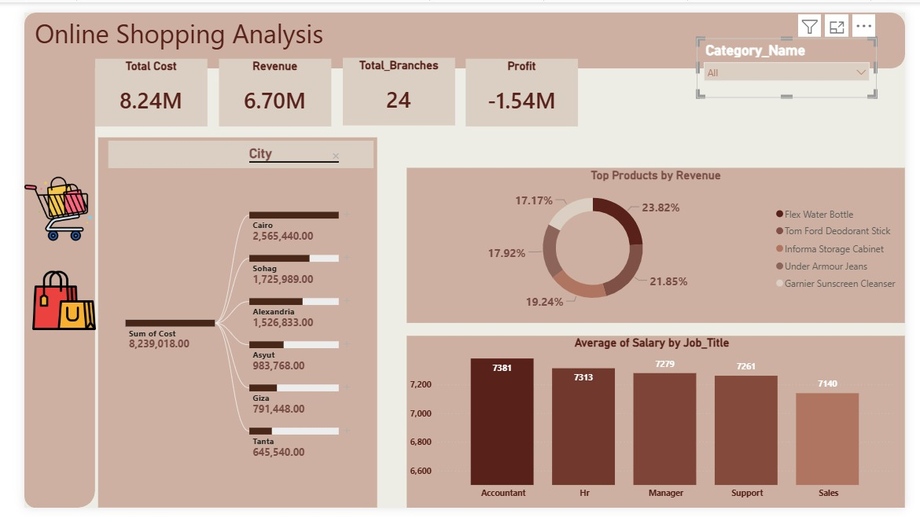
Dashboard 1

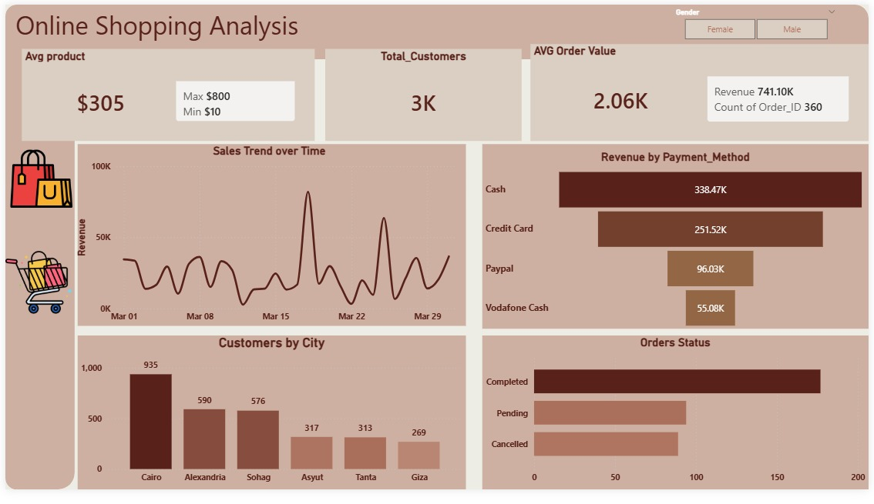
Dashboard 2

